**JAVASCRIPT: GETTING STARTED**

# Introduction and our first app

## Learning JavaScript in Plunker

# JavaScript beginnings

* Storing information in variables

## Understanding code errors

## String and numeric variables

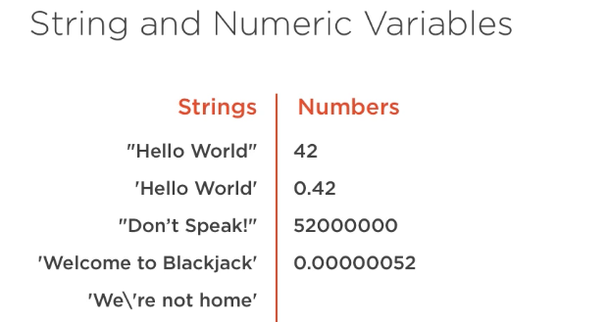

## Simple operators

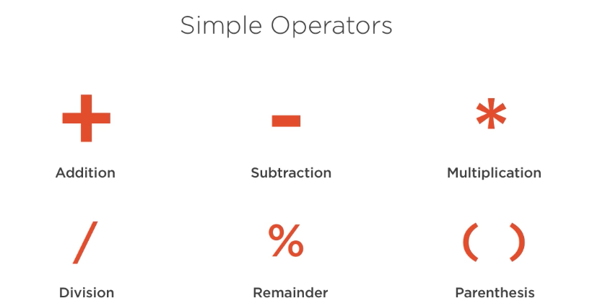

## Commenting code

## Starting our blackjack application

# Types and arrays

## Types basics: strings and numbers

## Boolean types

## Undefined ang null

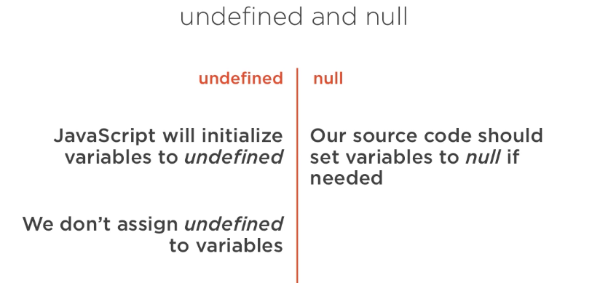

## Storing multiple values in arrays

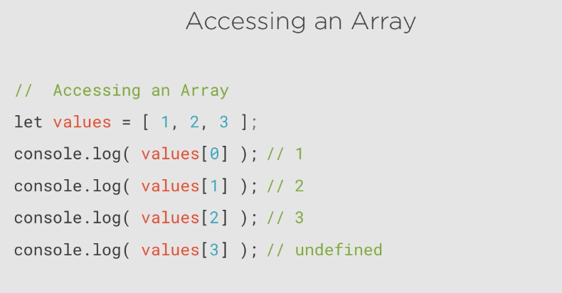

## Array features

* Add values
* Pop() : it popped off the last values, I removed it, when it removes that value can be store it I a variable if we’d like

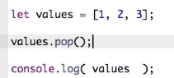



* Shift() similar to pop() but the first value



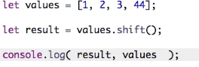

Result



* Splice(index, how many item want to delete, insert ….) 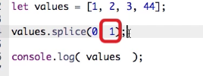

Use splice delete item then insert value respective to item was delete

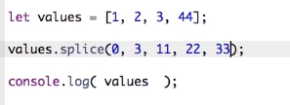

Result



# Program flow

## Conditionals using if()

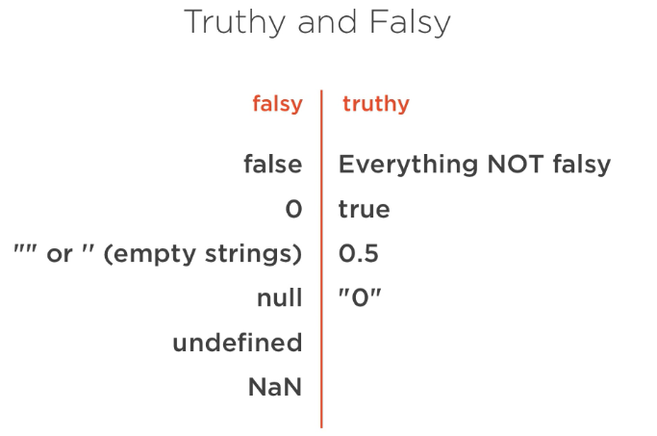

## If …..else

## Switch and case

## Looping with for

## Looping with while

## Adding loops to Blackjack

**Funtions**

* Function Basics
* Passing information to Functions
* Function return values
* Function scope
* Adding functions to blackjack

**Objects**

* Object basics

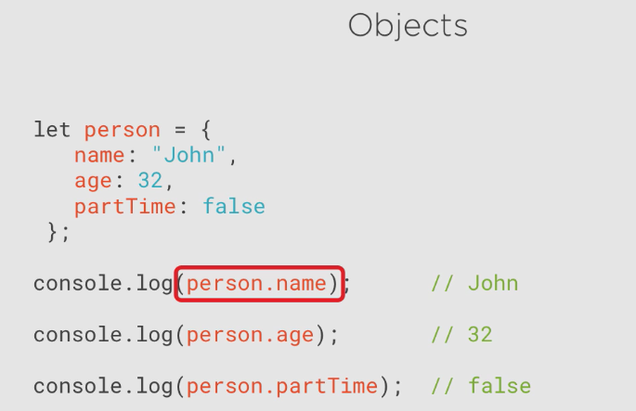

* Passing objects to functions
* Arrays of objects
* JavaScript build-in object

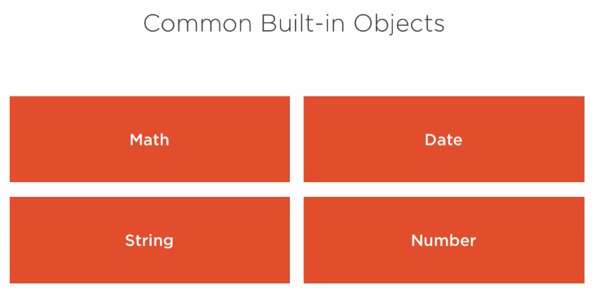

<https://developer.mozilla.org/en-US/docs/Web/JavaScript>

* Adding objects to Blackjack

**Programming for web pages**

* Setting up a web page

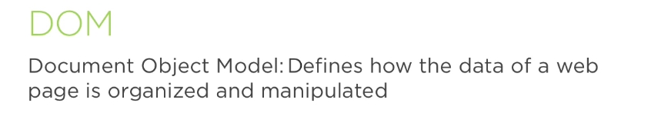

* Changing text

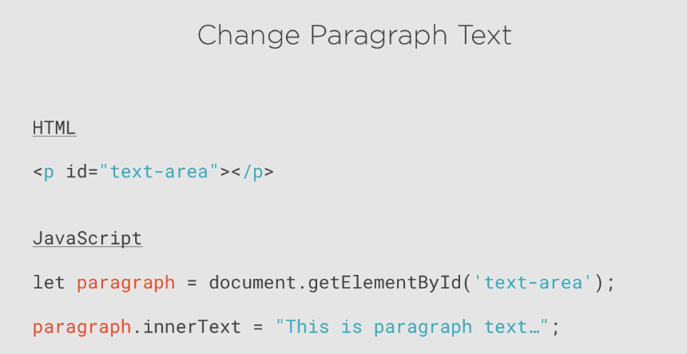

* Handling a button click

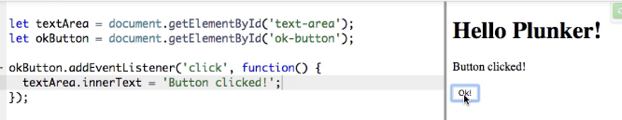

* Removing and adding elements

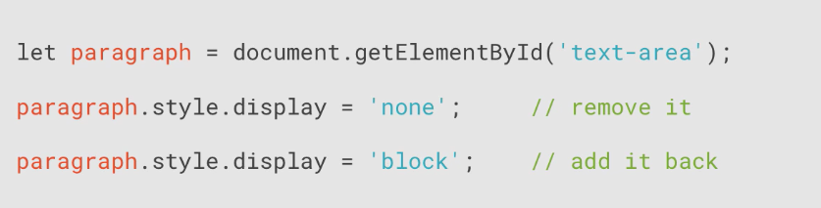

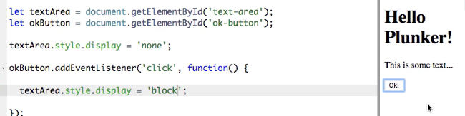

* Adding a user interface to blackjack

**Finishing our application**

* Setting up the Game
* Shuffling cards
* Calculating the Score
* Taking a Card or Staying
* Completing the Game